**TOPIC** Olympic Medal Wins

**RATIONALE**

We are commissioned by BEATS to analyze data on Olympic medal wins to be used in their preliminary decision to sponsor a country in the Olympics as their marketing strategy to increase BEATS headphones sales globally. The study will encompass Olympic game history from 1896 to 2016.

The main visualization will display a global map highlighting countries that have participated in the Olympic games and their respective aggregate number of medal wins. We will attempt to animate the visualization by showing the increase in medal wins of the countries over time (years).

We will have two supporting visualizations.

1. Bar graph – The bar graph will show the top 10 athletes with the most medal wins.

X axis – Athlete’s Name

Y axis – Number of Medals

1. Line Graph – The line graph will show the total number of medals won by women vs men through time.

X axis - Years

Y axis – Number of Medals

As an additional component, we will add an event that toggles the data between results of the Summer and the Winter Olympics.

**LINKS TO DATASETS:**

<https://www.kaggle.com/jeffksw/olympics-history-medals/data>

<https://github.com/eesur/country-codes-lat-long/blob/master/country-codes-lat-long-alpha3.json>

<https://datahelpdesk.worldbank.org/knowledgebase/articles/898590-country-api-queries>

**INSPIRATION SCREENSHOTS**

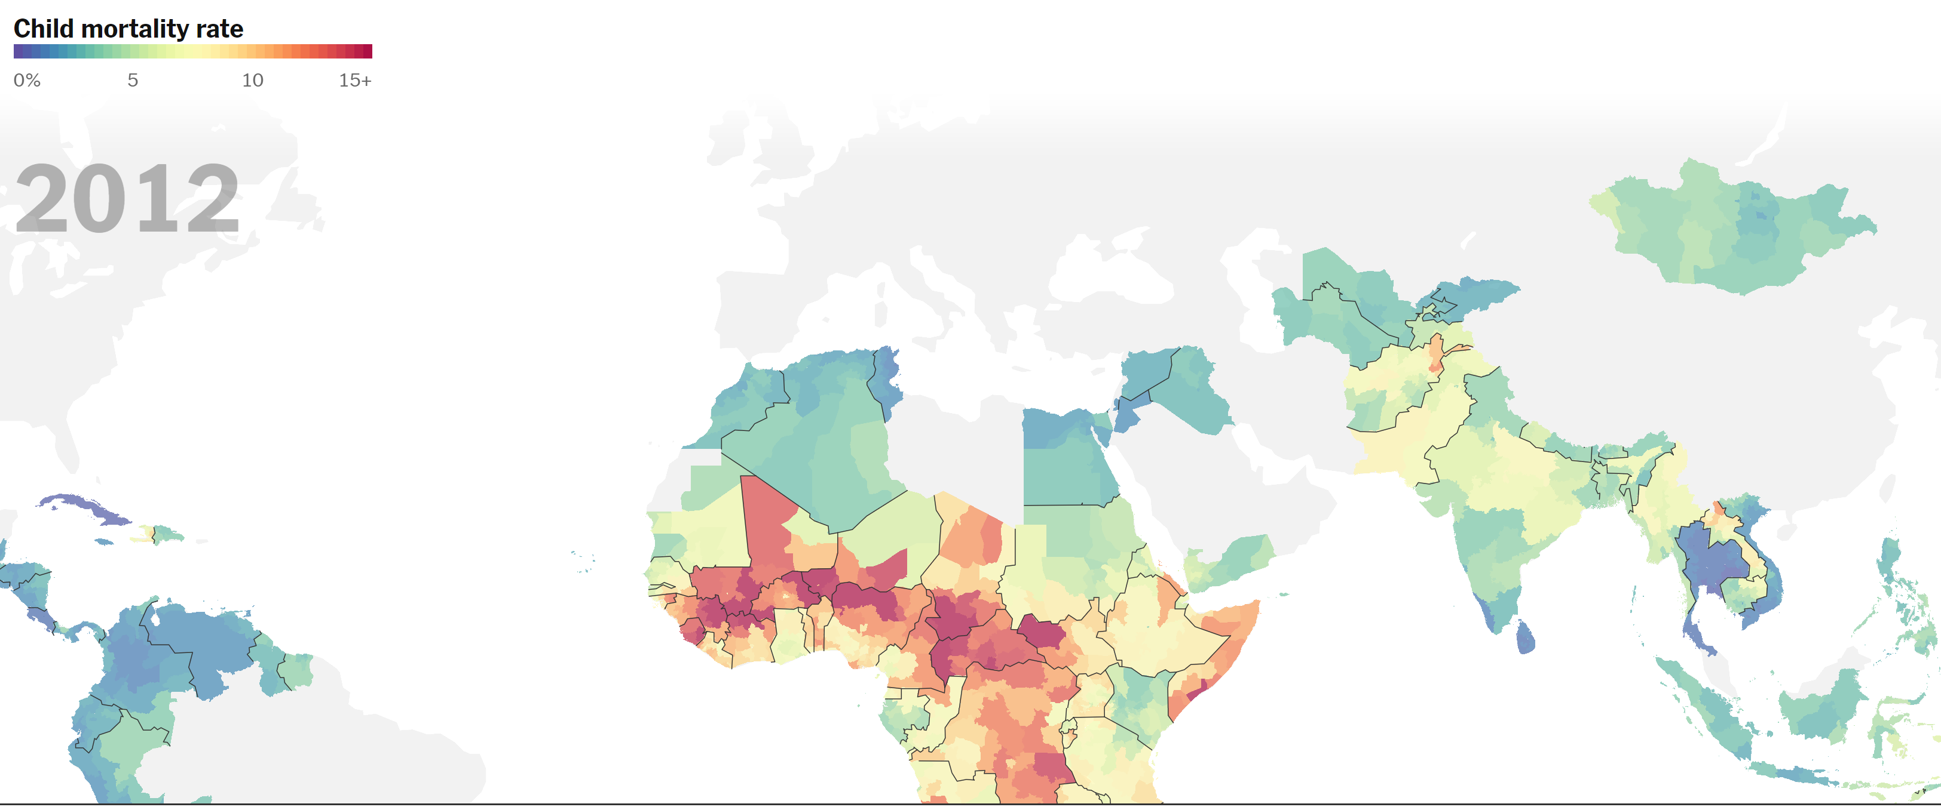

**HTML TEMPLATE**

